**Week 5:**

Create an online shopping web application using HTML, Javascript and Database:

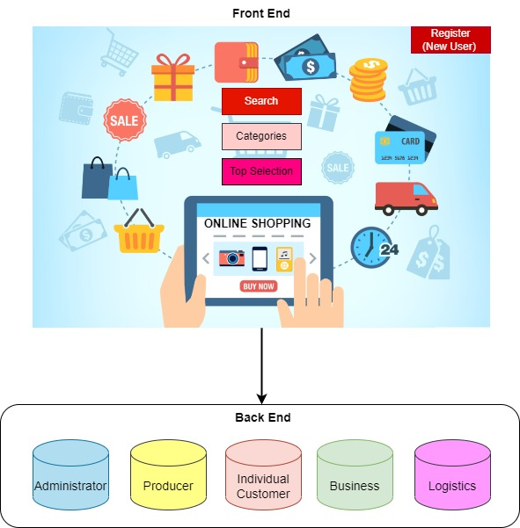

**Basic Features of the APP:**

* Only registered user can place orders
* Registration required for new users
* The frontend should have three modules : Search, Categories and Top Selection
* Search module lets the user to search for the Main product (Ex. Clothing)
* Categories module lets the user to choose different categories (Ex. Men, Women, Children)
* Top Selection module displays product name, product ID, rating, price, quantity in-stock

* The backend should have five modules: Administrator, Producer, Individual customer, Business and Logistics
* Administrator module monitors the entire application
* Producer can add and delete products (include product details while adding)
* Individual customer makes simple purchase orders and provide address for delivery
* Business person makes bulk purchase orders and should provide their address and the items they are dealing with
* Logistics module provides information about potential suppliers, accessibility and shipping details

* The application should provide the following functionalities:
* Add to cart option for the customer
* Should be able to see if the item is in-stock and the supplier details
* Discount coupons using supercoins
* Able to check the in-voice generated

**Note :**

1. Customize the App with additional functionalities on your own
2. Provide how your App differ from the existing online shopping APP